SPOILER HEAVY:

Dunder Dig <place holder title> is (going to become) an earthbound - Undertale – Yume Nikki- Mario rpg funny game with harvest moon – mega mine farming sim elements and duck tales - shovel knight gameplay .

Premise : (SPOILERS, DO NOT READ)

Game starts out in a harvest moon kind of thing : “oh you’re new in town! Well blah blah blah start digging to progress the story!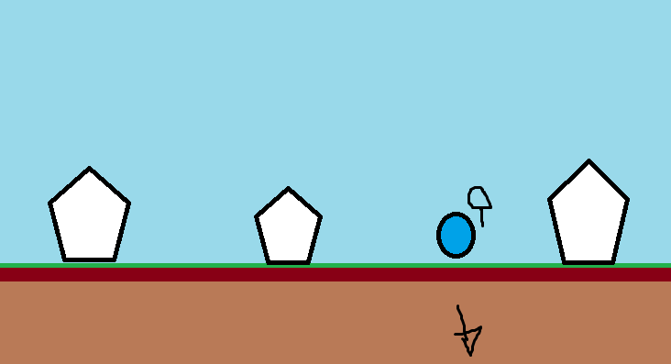

As you dig, you collect resources to progress your character’s stats: [shovel, HP, etc.], the plot and the story. Story and plot are not used interchangeably. Henceforth, ’Plot’ will refer exclusively to the events that take place in the game, and ‘Story’ will refer to all lore details before after and including the events of the game.

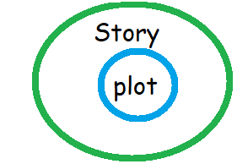

**[Super-duper spoilers]**

The ending of the game will hint that the whole game took place inside the brain of someone (dying?), and that you have been recovering memories of their collapsing mind. These memories take the form of recovered “ancient” diaries or tablets or something, that can only be deciphered or recovered if the character gets most of all of the collectables in the game. There will be other details hint this as well. It will be sort of obvious at least towards the end. Also, some characters will be brain puns. The mayor’s name will be ‘Mayor Nero’ (neurotypical, neurological, (also a blatant foreshadow that the mayor is evil (will be revealed to be not evil towards the end. The whole point is that the player thinks his name is Nero because he is evil, not because it’s a brain pun.)

**Level 0: The tunnel.**   
  
Opening cutscene (after player hit’s NEW GAME from the main menu). Screen fades to black, and then after loading, a ‘spotlight’ reveals the main character <not named yet> in a dim room. The only way to progress is to move right. (2d platformer controls.)

There are two stone tablets in the room. The first one from the left reads ‘Arrow keys to move’. The second one reads ‘Press ‘z’ to read signs’. (Haha funny joke c: )



The hallway is long enough to show off that camera will follow the player as they move. One-screen later (same loaded room, camera just has panned at least one screen’s length by now). The player will have to jump up a ledge. Another stone tablet is on top of the ledge and reads ‘Press up to jump’. They can exit the room to the right.



The next screen will be even more dimly lit. The background will have a brick- tile design, and then it will reveal a tiny dark alley in the background. If the player interacts with the alley, it will say “It’s too dark to see anything”. If player makes it to the right side of the screen, a cutscene occurs:

Slick <name pending> calls out to the player from the alley. {back-alley music from trails from zero plays}

Slick is a shady, slim, dark pointy character wearing an overcoat.

Slick: Well, we got a newcomer here. The name’s slick. Blah blah blah blah. Why doncha buy somtin?

Character: [buy somtin, don’t ]. If the player selects ‘buy’, it will say “you don’t have any money”. If the player selects ‘don’t’, :

Slick: Cheapskate, huh? Well don’t say I didn’t warnya . I bet you won’t last 10 seconds out there! Hehehehe. *Walks back into the alley*

Character progresses to the right and enters Quarton (Note: Quarton is a portmanteau of ‘Quarry and Town’. It’s also a pun on ‘Carton’ and the number 4. ), a very bright, happy grassy, green sunny village will happy music.

First thing they player sees are some NPCs and a big sign that says, ‘Welcome to Quarton’. Infront of the sign is an NPC that says, “Welcome to Quarton!” . Another NPC to the right of them says “She has a horrible condition where she can only say “Welcome to Quarton!” . Interacting with them a second time, they say, “It’s a good thing we live here! What a coincidence!”

Walking a little further, and the player reaches the farm. At the farm the player meets (Mayor Nero <pending>) and somehow exposition they need to dig in the farm in order to progress the plot. Nero leaves. The player then encounters Slick again, and he is willing to sell you a shovel for free, (you have to pay him back). Now this game is animal crossing because your first tangible goal is to not be in debt any longer. This also provides a tutorial opportunity to explain to the player that digging yields resources.

The formula for the rest of the game:  
Player digs, collects resources (Mega Miner). Occasionally encounters obstacles that require either a key item or a better shovel (obtained through story progression/ trading resources). The player also occasionally discovers ancient tombs. The tombs are self-contained dungeon instances. Also, each level will have its own signature platforming mechanic that it will focus on, in addition to having several unique powerups throughout the level. The final reward for finishing a dungeon is an ancient relic that needs to be researched in the library in the overworld.

**Overworld:** Snowden from Undertale. Contains a library where you can research relics. Initially, most of the village is inaccessible because (obstacle) and you need to research your first relic to access the rest of the village.

**Level 1:** The player plays through some easy platforming, and then encounters 4 Bean shaped NPCs (dug trio). Their names are Jelly, Pinto, Fava, and Charlie. The first three introduce themselves as the “Three Bean Gang”. And then Charlie says “And I’m Charlie! (:< “. The other three are constantly reluctant to include Charlie. They represent an antagonist, by creating obstacles for the player, (this is how the game will teach the player the platforming mechanics). Eventually (second of third encounter), the beans will have a fight, and kick Charlie out of their group. Charlie can join your party! The very next screen, there is a ‘bean-shaped’ hole . “Only a bean could fit through here”. The player will need to have asked Charlie to join their party in order to progress. Interacting with the hole, Charlie will say “Heh, only a bean could fit through there.” Interacting a second time, Charlie will say “hmm I bet you think I could fit through that hole and open the door from the other side! No , that could never work.” And then a third time, Charlie will say “I know! I can turn you into a bean, and then you could fit through the hole!” [Turn into a bean, don’t turn into a bean].

The level continues, as you try to reunite the three beans, and Charlie back together. Reuniting the beans constitutes ‘key items’ in the dungeon, gaining further access to the rest of the level. The ‘boss’ is Frank. (Frank-n-Beans). Lot of bean jokes in this level.

Suggestions: More gore?